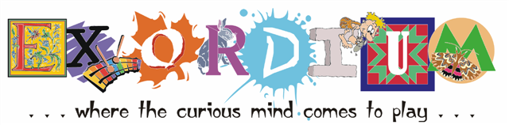

Tails & Tales – Library Summer Reading Theme 2021

**Program I – The Tale of an Important Tail!**

This program takes a closer look at the tails of animals & birds. We will explore what those tails are actually used for by their owners while being able to handle a number of real tails.

**Program II – The Tale of a Kite’s Tail**

This program look’s at the kite through-out history, the materials with which they were constructed and what we have used for through the ages. Finish up your learning by making a simple kite to take home.

**Program III – Riding a Comet’s Tail Through Space**

The comets in our night skies have always held our fascination. In this program, learn what a comet is made of, why it has a tail and comes to visit on a regular basis. You will also be building your own comet model.

**Program Requirements:**

Exordium programs are completely self-contained and the only requirement are a power supply & a table to stage materials as well as adequate room for participants to either work on their craft or investigate phenomena in small groups.

**Program Costs:**

Single program - $165.00 + mileage from Enosburg Falls. Multiple program booking & block booking discounts available

**Special Note:**

Materials for the programs will be supplied unless large summer camp groups of over 20 participants are anticipated. These may incur an additional charge or be asked to supply their own materials.